1. **Linux common commands and the use of vim editor**
2. **Some basic common**

1) View the version of operating system

cat /proc/version

1. View the version of mainboard

cat /proc/cpuinfo

1. View the remaining space of the SD card.

df -h

1. View IP address

ifconfig

5)Condense：tar –zcvf filename.tar.gz dirname

Decompress：tar –zxvf filename.tar.gz

1. apt(Advanced Package Tool)is used to install software.

sudo apt-get install xxx install xxx software.

sudo apt-get update update software.

sudo apt-get upgrade Update the installed software.

sudo apt-get remove xxx remove xxx software.

Some tutorial for linux commands:

<http://www.runoob.com/linux/linux-command-manual.html>

1. **Introduction and configuration of the vim editor**

Linux comes with editors nano and vi. Vim editor is an upgraded version of the vi editor,which has a better experience.

**The following steps will teach you how to install and configure vim editor in the Raspberry Pi system**

1)You need to input: sudo apt-get update

2)You need to input: sudo apt-get install vim

You will see the following interface:

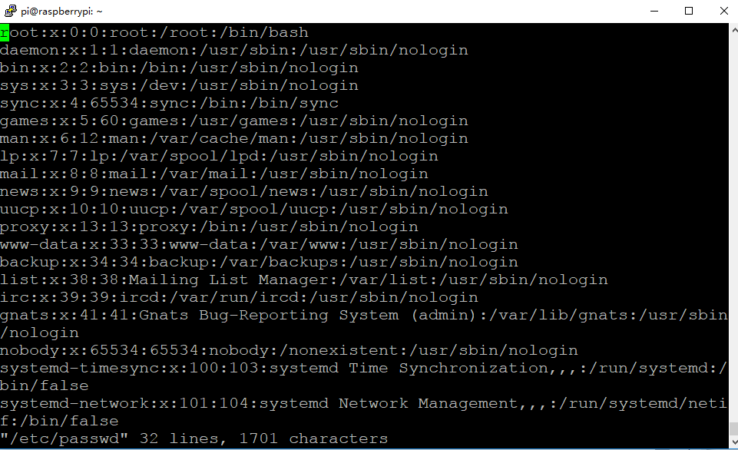

3)You need to input: su and input the password for the your root account.



4)You need to input: sudo tar xvf vimconfig.tar.gz

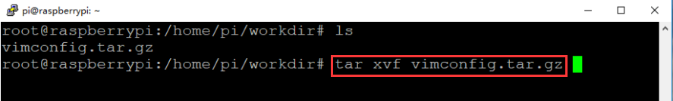

5)You need to input: cd vimconfig

You need to input:./config.sh

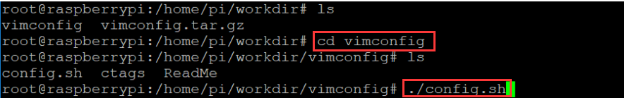

You may see the interface shown below.

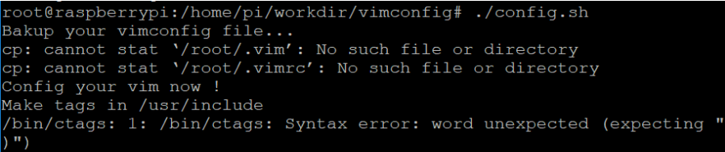

6)You need to input: touch /root/.vim /root/.vimrc



7)You need to input: apt-get install ctags

2017-08-29_114520

After the above steps is completed, the vim editor becomes will become as shown below.

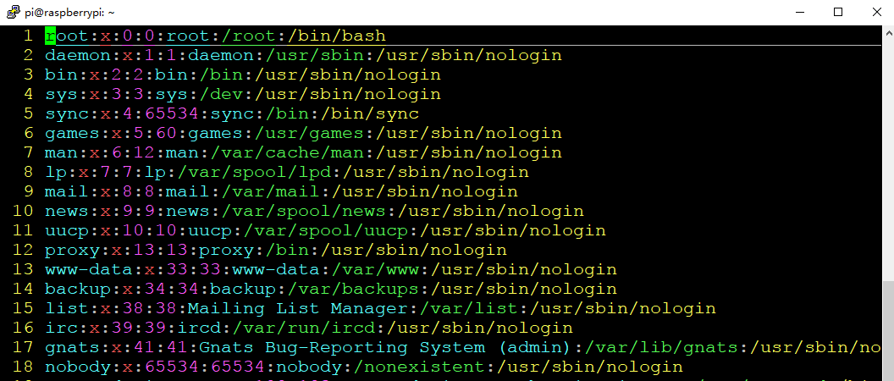

The editor possess 3 modes: Enter mode, Command mode, Low line mode.

Enter mode:In this mode, you can enter characters, and pressing ESC will return to command mode.

Command mode: You can move the cursor, delete characters, and so on.

Low line mode: You can save files, exit editor, set editor, find,etc.(low line mode be regarded as in command mode)

①These instructions are used in Command mode:

vi filename/vim filename //Open the filename file

:w //Save file

:q //Exit editor(The file has not been modified)

:q! //Exit editor without save

:wq //Exit editor and save

②These instructions are used in Command mode.After these commands are executed, you can enter the Enter mode. (pressing ESC will return to command mode)

a //Add text to the right of the current cursor position

i //Add text to the left of the current cursor position

A //Add text at the end of the current line

I //Add text at the beginning of the current line (the beginning of a line that is not a null character)

O //Create a new line above the current line

o //Create a new line below the current line

R //Replace (overwrite) the current cursor position and several texts that follow

③These instructions are used in Command mode:

x //Delete current character

nx //Delete n characters from the cursor

dd //Delete current line

u //Undo the previous step

U //Undo all operations on the current line

④These instructions are used in Command mode:

yy //Copy the current line to the buffer

yw //Copy the characters from the cursor to the end of the word

y^ //Copy the content from the cursor to the beginning of the line

y$ //Copy the content from the cursor to the end of the line

p //Paste the contents of the clipboard behind the cursor

P //Paste the contents of the clipboard in front of the cursor

⑤These instructions are used in Command mode:

:set nu //Display the number of line

:set nonu //Undisplay the number of line